Beech Tree

**Pontville School - Residential**

**Statement of Purpose**

**Head Teacher: Mrs H Dorian**

**Head of Care: Mrs H Dorian**

***Statement of Purpose***

**Contents**

The Aims and Objectives of Pontville’s Residential Provision 3

Location and Accommodation 3

How to find us 5

Caring for Children 5

Ethos and Culture 6

Achieving Positive Outcomes……………………………………………………………………………………………..…6 Social, Sporting and Cultural Activities 7

Placement Plans 7

Religious and Cultural Ethos 8

Contact between Children, Families, Relatives And Friends 8

Consultation with Young People 8

Equal Opportunities, Anti –Discriminatory Practice and Children’s Rights 9

Referral and Admissions Process 9

Compatibility and Matching 10

Making a Complaint 11

Safeguarding 11

Missing From Care / Education 12

Individuality and Positive Group Living 14

Education 14

Health 15

Therapeutic Services at Pontville 15

Therapeutic Model 16

Measuring the Effectiveness of Therapeutic Support…………………………………………………………….17 Staff Training, Development and Supervision 17

Organisational Structure 18

Governance 18

Children’s Behaviour 18

Mechanical or Electronic Means of Surveillance 19

Emergency Procedures 19

Contact Details 20

Staffing Matters – Residential Staff Team 20

## The Aims and Objectives of Pontville’s Residential Provision

Pontville School specialises in supporting pupils with Autism Spectrum Condition, Asperger’s Syndrome and Speech Language and Communication Needs between the ages of 5 to 19. In order to cater specifically for their needs the school employs a therapy team consisting of Speech and Language Therapists, Occupational Therapists, Therapists, Educational Psychologist and Assistant Psychologists. All staff undergo communication training as part of their induction. The curriculum is adapted in order to integrate the learning of communication skills into all aspects of the school day.

Pontville’s residential provision continues to be judged as Requires Improvement in all areas from our Ofsted inspection in December 2024.

Our residential ethos is to create a caring, supportive, safe and secure learning environment, in which young people are encouraged to develop their full potential, using a wide variety of methods. We aim to treat each young person as an individual, recognising their different needs and celebrating their strengths. We strive to develop all the young people’s capabilities whilst promoting their self-worth and self-esteem.

We are committed to providing a safe, nurturing, caring and stimulating environment for young people, where issues and concerns affecting both their past and their futures can be positively addressed and supported. Working in partnership with each young person, their families and other professionals, we endeavour to enhance each young person’s achievement possibilities, raise levels of self-confidence and self-belief and create opportunities to learn, develop and achieve.

Whilst in Pontville’s Residential Provision we will actively encourage the young people to develop friendships with peers and adults, and to continue the development of independence at a level and pace in accordance with their understanding and ability.

## Location and Accommodation

Pontville’s Residential Provision is situated within the main school site. The school sits in its own grounds on the outskirts of the local market town of Ormskirk. We provide a high quality living experience within a welcoming and warm homely environment.



There is access to a variety of local activities such as local youth clubs, trampolining, parks, woodlands, local beaches and a leisure centre including a swimming pool and gym. We also have access to the school farm and Forest School area. Opportunities are provided for young people to access local facilities in either a supported, semi-independent or independent basis.

The school’s residential accommodation consists of two homes located within the main school building for pupil’s resident from Monday to Friday, term time only.

Our home Oakwood can accommodate up to seven young people. All of our young people have individual bedrooms with en-suite facilities. There is a large lounge, dining and kitchen area and a family bathroom.

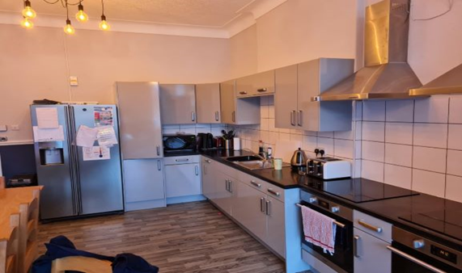

The wishes and feelings of the young people, as well as their compatibility, are taken into account in deciding where each young person lives. All pupils are encouraged to personalise their own rooms and to develop respect for privacy and comfort rights of themselves and other members of the home. The young people are given a forum during weekly meetings to discuss any issues they may have, activities they wish to undertake and what they would like for their meals. Keyworker sessions take place with all young people, giving them opportunity to discuss how they are feeling, their views and wishes.

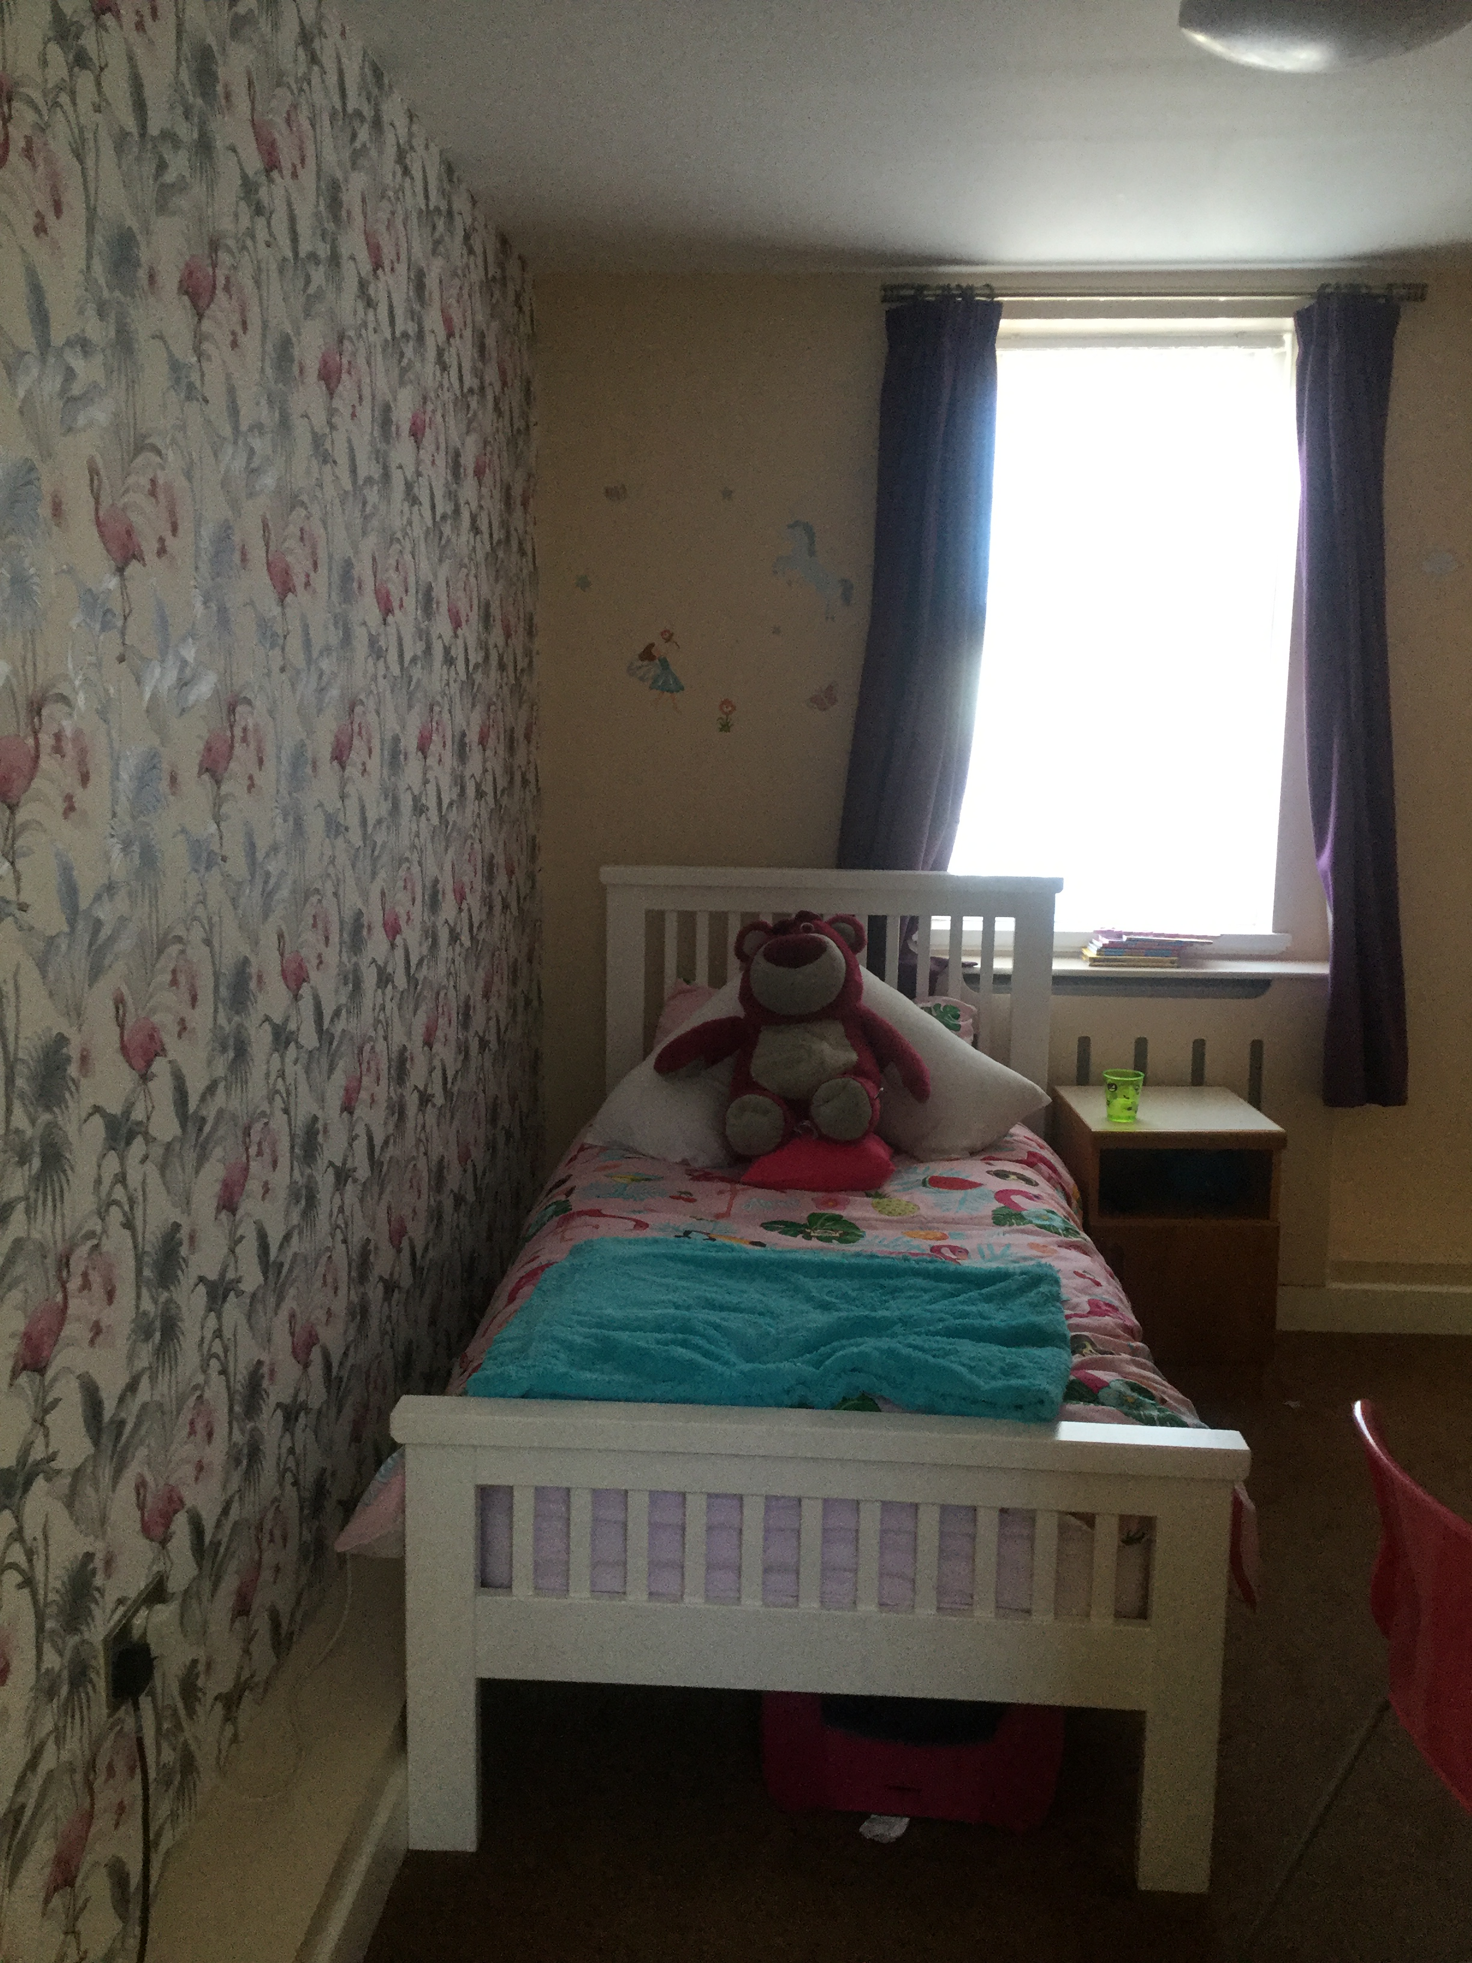All bedrooms are equipped with a colour television and internet access. The bedrooms are all personalised and furnished to a high standard, taking into account the needs and wishes of the young people providing space and facility for private study.

All children and young people who are resident have individual bedrooms that they can lock if they wish to ensure privacy and security. All young people have their own key but for safety reasons staff can gain access to bedrooms if necessary. All young people have a choice in the layout, decoration and furniture in each bedroom.

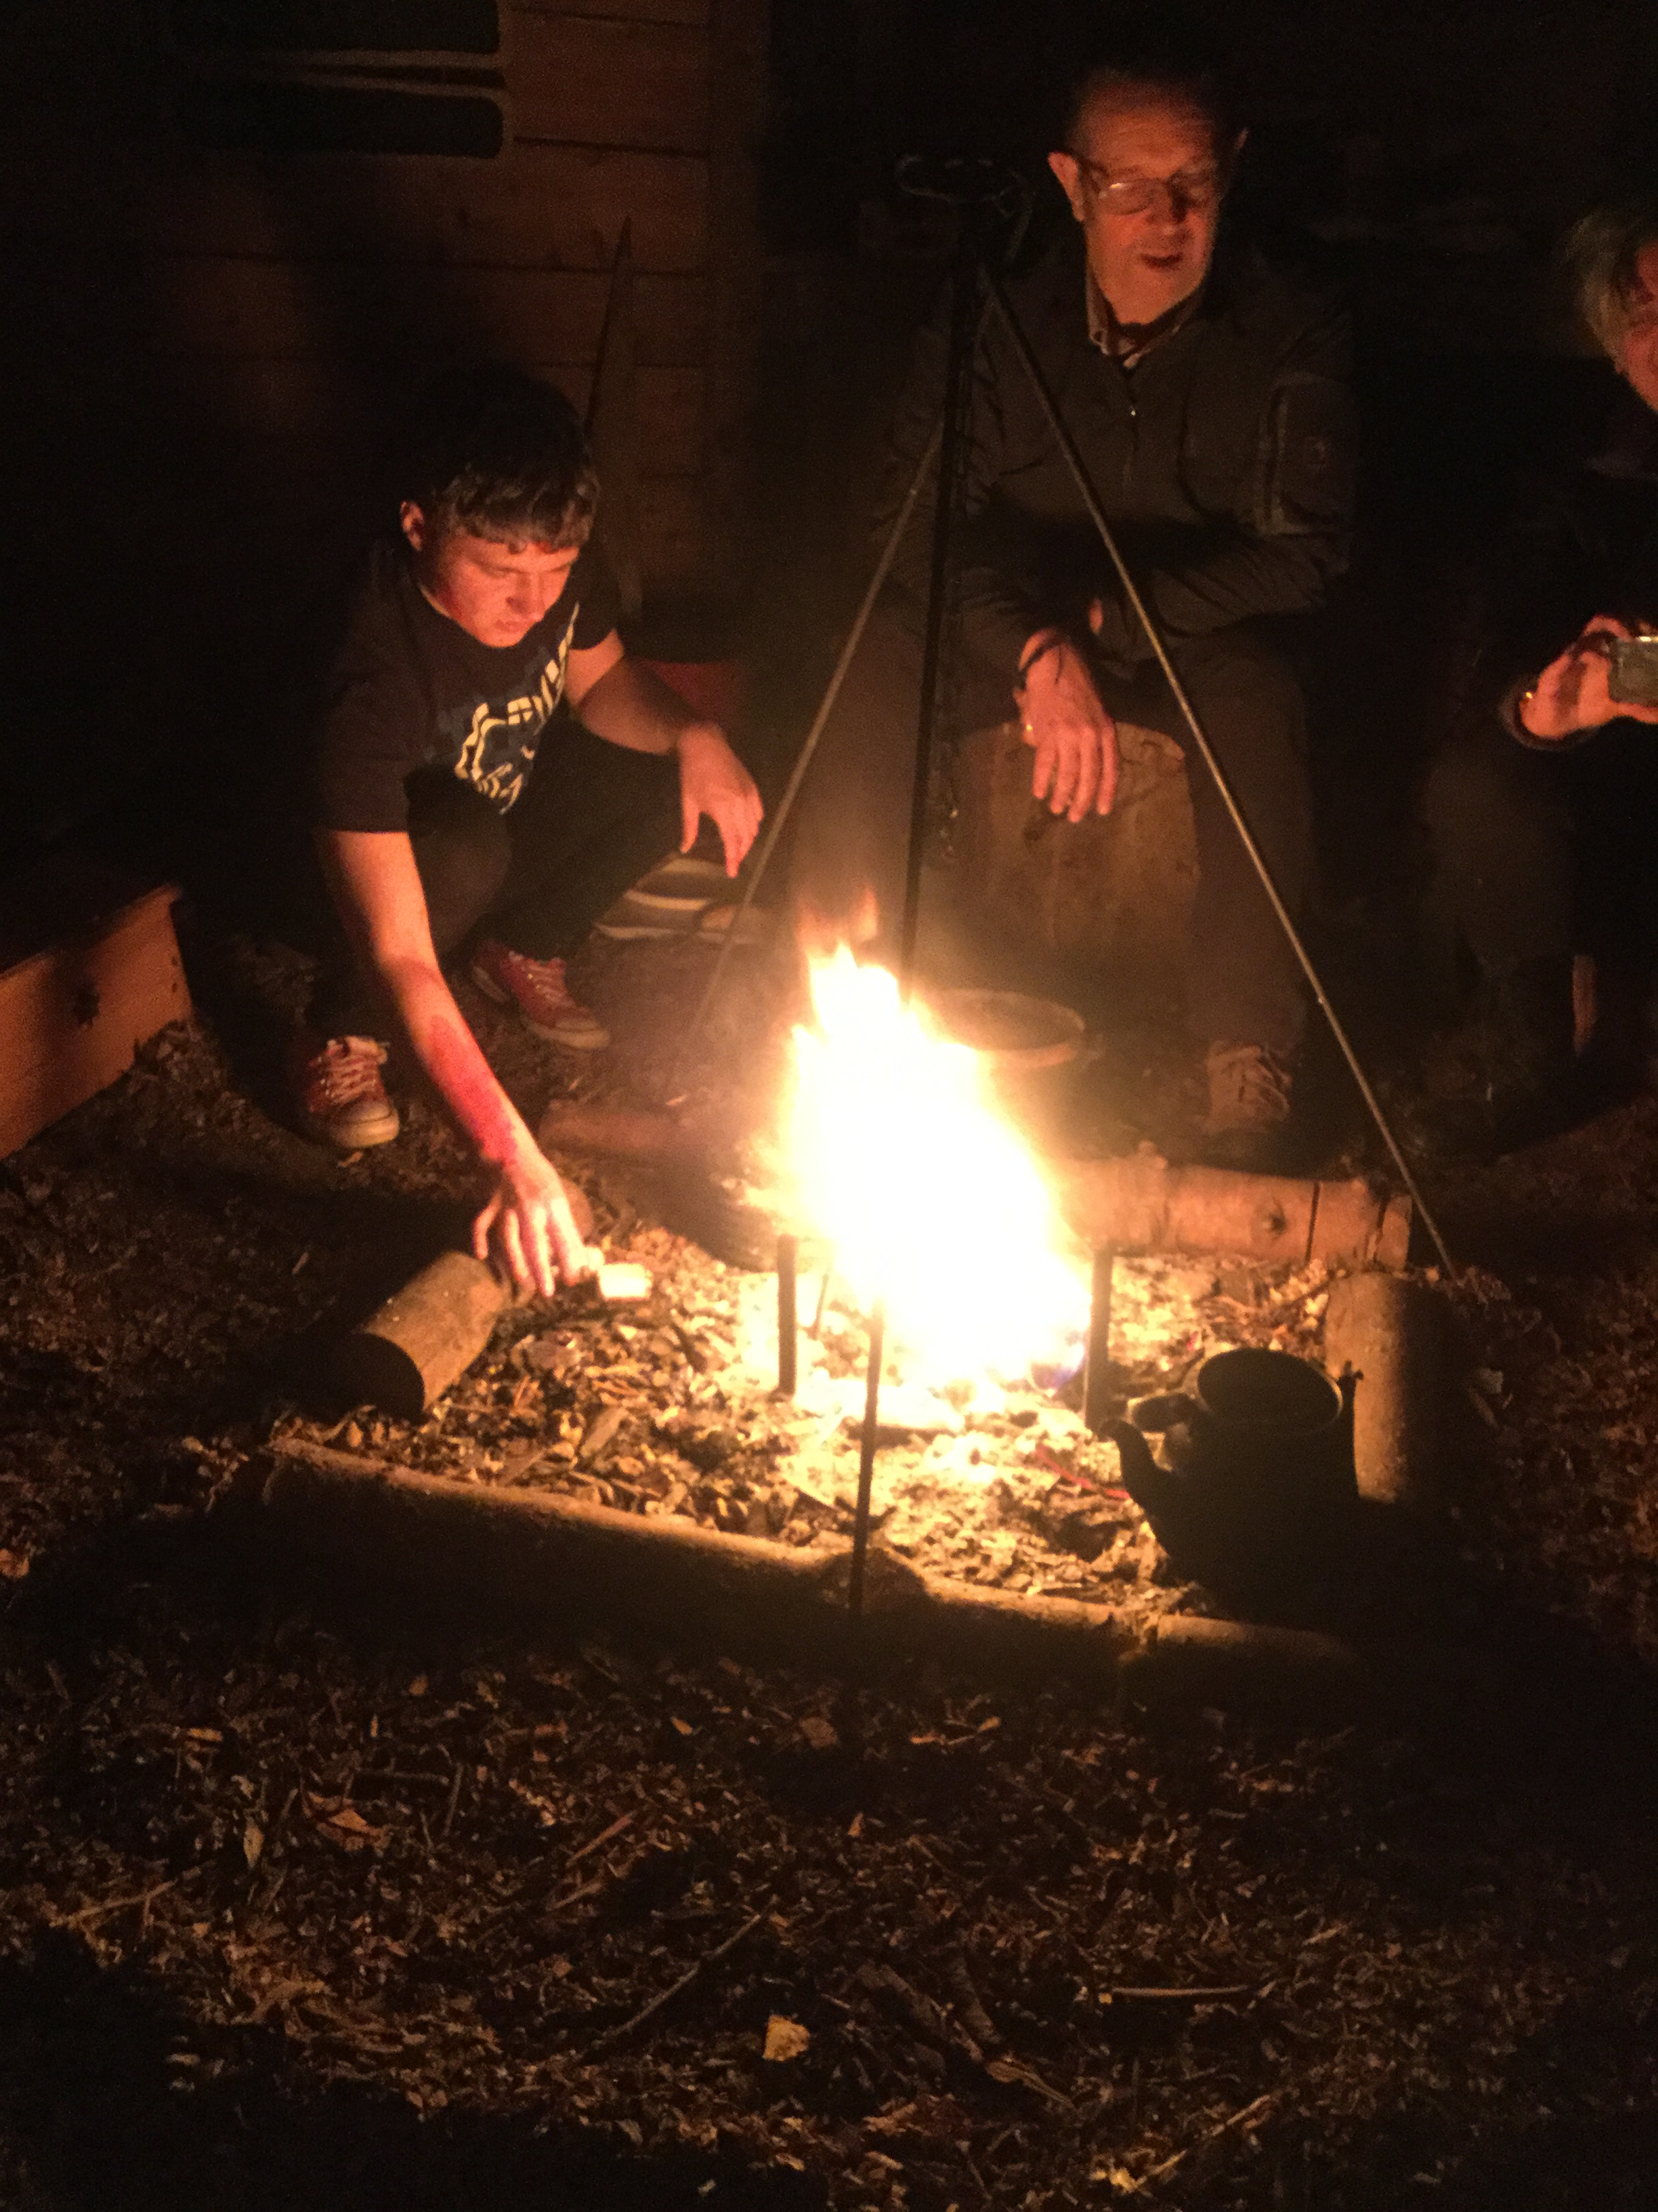

Externally the Grounds of the school are accessible to all young people who stay residentially. Young people can access the sensory garden, football pitch, MUGA, outdoor gym, zip wire, farm, forest school, sensory rooms or the Art room if they wish to.

The design of the residential homes allows for privacy and promotes independence opportunities for young people that meet their social, emotional and personal development needs.

Visitors are welcome at most times during the day and evening, but preferably not when young people should be at school or late at night. We provide children with appropriate privacy for visits involving family, friends, Social Worker and other supporting partnership staff.

## How to find us

**From M58:**

* Leave the M58 at junction 3 and join the A570 towards Ormskirk
* Continue on the A570 into Ormskirk passing the University on the right
* At the next set of traffic lights turn left onto the A570 towards Southport
* At the next traffic lights turn left onto the B5139 Aughton Street, you will pass Morrison’s on your right
* At the mini roundabout take the first exit onto the B5197
* Continue past the church on the left
* Take the next left onto Black Moss Lane
* You will find us situated on the right hand side

**From M6:**

* Leave the M6 at junction 26 and join the M58 signposted Skelmersdale, Liverpool, Southport
* Leave the M58 at junction 3 and follow directions as above.

**By Train:**

* Aughton Park is the nearest railway station.
* We are a ¾ mile / 14 minute walk from the station

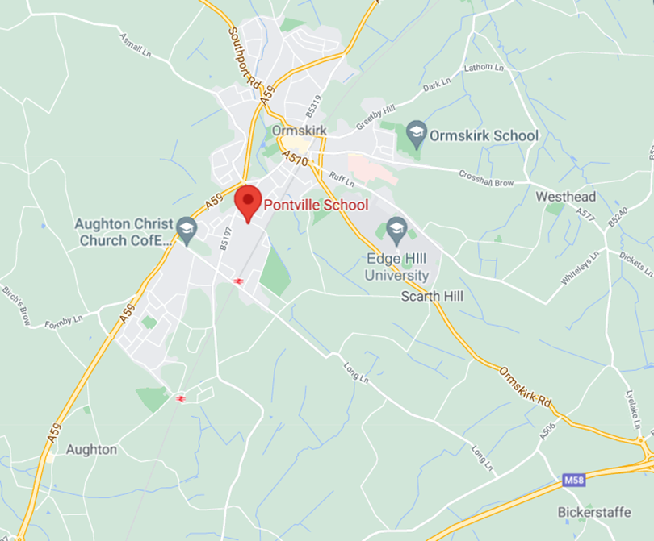

## Caring for Children

The Witherslack Group is committed to working in partnership with young people, parents/carers, social workers and placing authorities to best meet the needs of our young people. Every young person at Pontville Residential Provision House has a ‘Key Worker’ to ensure that the Individual Care Planning is effective, targeted and regularly reviewed.

The Witherslack Group maintains a very high view of young people and this is rooted in its philosophical base of ‘Resilience Theory’, which itself holds to the principle that–

***The individual has a combination of personal characteristics and skills that allow them to function beyond what would be expected in the light of that person’s vulnerability or exposure to adversities.***

It holds to a view of people that is positive and which has a high expectation of the individual’s ability to change.

## Ethos and Culture

The ethos and culture of Pontville’s Residential Provision is based on person centred principles which promote the development of meaningful relationships between staff and young people. Young people are at the centre of the work we do in trying to provide the most positive residential and educational experiences possible. These are based on the core values of mutual respect and good parenting, respectful to the values of privacy, dignity, independence, choice, rights and fulfilment.

All staff at Pontville’s Residential Provision have an active awareness of each young person’s racial, cultural, religious and dietary needs, and all children and young people will receive sensitivity in practice, especially when dealing with personal issues. We aim to equip young people with the knowledge and skills needed to make informed choices. We will support young people to develop these skills within a nurturing and appropriately structured environment.

## Achieving Positive Outcomes

Better outcomes are achieved for our young people, where there is access to responsive support designed to increase resilience and reduce problems. Good care planning and case management / tracking is fundamental to improve outcomes, in that it facilitates an appropriate response of services and decision making processes to the individual needs of each child or young person.

As a Care team we attend all meetings on our young people, we internally hold ITAC (Internal Team Around the Child) meeting’s to ensure as a staff team we identify areas of strength and development of the young people and provide a consistent approach.

For children and young people in our care, having some control over their lives is often extremely important. Working with young people in an inclusive, child friendly way to develop goals or define their own outcomes can help promote a sense of what the future might hold and how we reach it.

The homes approach to achieving positive outcomes for the young people we care for include:

* Involving children in discussions about their needs and their future
* Helping them to contribute to care plans and reviews, ensuring their wishes are always considered and where possible addressed
* Giving clear information, making sure that young people know about – the reasons for staying residential, their rights while they are with us, future plans and how they can influence these.
* Encouraging young people to make choices, state preferences and define outcomes for themselves and respecting these choices and preferences.

The purpose of providing young people with personalised packages of support, information, advice, guidance and learning and development opportunities is to improve their life-chances.

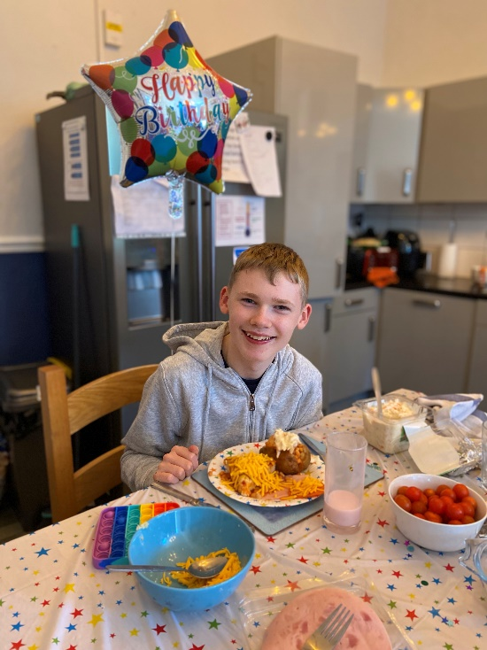

## Social, Sporting and Cultural Activities

All children in the Residential Provision are given the opportunity to actively engage in, and influence the planning and delivery of a wide variety of leisure activities which include holidays and day trips and access appropriate opportunities which involve young people recognising and managing calculated risk.

Young people are encouraged and supported in their participation in a wide range of social, recreational, learning and cultural activities. Staff management of these activities are based on their knowledge of a young person’s developmental capacity and independent skills, some young people will be able to access activities independently or semi-independently whereas others may require more staff support. Staff will assess each young person when they arrive with us and identify areas to improve skills and build a complete social development profile.

As well as supporting existing hobbies, we offer young people the opportunity to discover and develop new individual interests and hobbies which allows for the development of wider social networks. Many young people join local youth groups or community-based sports activities with some young people sometimes having part-time jobs. We understand that it is important that young people feel that they are part of the wider community and that they also have something positive to look forward to.

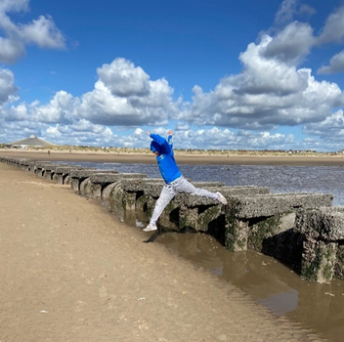

Each young person in Pontville’s Residential provision will work on AQA units, during their time with us. These are designed around social skills. They are targeted to be age appropriate and based on adding to their life skills. We actively encourage all young people to help identify what they want to work on, in order to help them have ownership.

## Placement Plans

All young people have a comprehensive placement plan which includes: the day to day routines, contact arrangements, family details, education arrangements, health care, consents for medical treatment, risk assessments, PEP, identity, Social development profiles, social and leisure activities which is reviewed on a minimum half termly basis or as circumstances dictate.

A review of arrangements will be held within 12 weeks of placement in line with a school post admission review. It is the responsibility of the key-worker, under the guidance of the head of care, to monitor and ensure that the requirements of the care plan are implemented in the day-to-day care of each young person.

## Religious and Cultural Ethos

The religious and spiritual needs of young people is central to their identity and welfare and our Residential Provision is proactive in supporting them in these aspects. We are sensitive and respectful of the religious and cultural needs of all the young people and their families, and welcome information prior to admission concerning any specific requirements. Young people will be supported in any religious observance of their choice as well as work aimed at increasing young people’s awareness, understanding and acceptance of different faiths. Young people are actively encouraged to maintain cultural links, and this is supported by a culture in the school which recognises individuality and celebrates diversity. We will support a young person to attend a service or receive instruction in their chosen faith as well as supporting them in other aspects of religious observance such as diet and dress for example.

## 

## Contact between Children, Families, Relatives and Friends

All of our young people are resident Monday to Friday, going home at weekends and school holidays. Children and young people who stay at Pontville’s Residential Provision will be actively supported in maintaining contact with parents, family and significant others, throughout the week. All Staff actively promote family contact, as appropriate and agreed in the placement plan for each young person. Contact is supported in a variety of ways including visits, telephone contact, Social media (where appropriate), email, school parents’ evenings and reviews.

## Consultation with Young People

We believe that Pontville’s Residential Provision functions best and the young people living here are happiest when they are routinely consulted about events, actions and decision which affect them. Consequently the home has in place a number of formal and informal systems designed to involve young people in active decision making. All children accommodated at Pontville Residential Provision will be made aware of their rights and how they access independent advocacy services, Children’s Rights Services and Ofsted.

All children and young people at Pontville Residential Provision are actively encouraged and supported to share and influence the day-to-day routines and practices within the home through a variety of means, including daily discussions, young person’s meetings, menu and activity planning and regular planned key worker sessions. Other more practical examples are the purchasing and choices regarding resources, furnishings and decor in the home. Young people are encouraged to be involved in discussion and decision making about developments within the home and actively contribute to the residential development plan.

Consultation with young people involves adults working with children and young people to ensure that their views are heard and valued in the taking of decisions which affect them and that they are supported in making a positive contribution to their home.

Participation and involvement from young people, their families or carers, friends and support staff (i.e. social workers) is embedded into the heart of our services for care and education within the Witherslack Group. We feel young people’s involvement (and other key individuals) are crucial to them taking ownership, developing self-esteem and establishing the wider skills they will need to succeed in life.

The young people in our care share responsibility for decision-making within the home environment. The young people are involved in the decision-making process around menus, activities and holidays, child looked after reviews, 1-1 key workers sessions, their pathway planning and are regularly consulted about staff and their approach in the manner of “the voice of the young person”.

## Equal Opportunities, Anti – Discriminatory Practice and Children’s Rights

Pontville’s Residential Provision has an equal opportunities policy which aims to ensure that no job applicant, employee, young person or prospective young person is discriminated against whether directly or indirectly on the grounds of age, gender, attainment, special educational needs, ethnicity or cultural background. Pontville’s Residential Provision operates a ‘zero tolerance’ approach towards discrimination and extremism in all its forms.

We believe that all young people have the right to be listened to, to have their views respected and to be able to feel safe, free from abuse, fear or oppression. A key focus of life at Pontville’s Residential Provision is in helping young people to gain a greater understanding not just of themselves, but also of other young people, adults and the wider community. With rights come responsibilities and it is important that young people learn the value not only their own rights, but also the rights of others.

Our aims are:-

* To ensure young person's opinions and those of their families or significant others, are sought over key decisions which are likely to affect their daily life and their future and that feedback will be given after consultations;
* To balance properly young peoples' rights and responsibilities;
* To raise awareness of the relevant provisions contained within the European Convention on Human Rights as they apply to UK law (as contained within the Human Rights Act 1998);
* To establish our position that as an agency acting on behalf of Local Authorities (by way of our core function to provide care for their children) we are cognisant of our responsibilities and liabilities as a 'public authority' and will act in accordance with the Convention Rights;
* Young people will be encouraged and supported to make decisions about their lives and to influence the way the home is run;
* Young peoples' privacy will be respected and information about them will be confidentially handled;
* Young people's complaints will be addressed without delay and young person will be kept informed of progress in their consideration;
* Guidance and training on consulting with and involving young people, their families and significant others will be provided for staff;
* The religious, racial, cultural and linguistic backgrounds of young people and their families will be taken in to account by staff who will be encouraged to ask for advice and assistance when necessary. Staff will ascertain and take into account the views and opinions of young people, their families and significant others. Feedback will be provided following consultations. The views and opinions of young people on all matters affecting them including day to day matters and major events will be ascertained and not taken for granted;
* Each young person, as far as is practicable, will be able to attend the services of, receive instruction in and observe any requirement of (including dress, diet or otherwise) of their religious persuasion.

## Referral and Admissions Process

Initial enquiries and informal visits are welcome by appointment. Formal application for placement is made through the young person’s Local Authority. Applications should be accompanied by their Education Health Care Plan along with school and social reports and any other professional reports.

Pontville Residential Provision caters for young people who have complex needs and may be experiencing a range of difficulties including:

* Autistic Spectrum conditions;
* Communication difficulties;
* Attachment disorders;
* Asperger’s Syndrome;
* Developmental delay requiring a highly modified curriculum;
* Mental Health issues;
* Dyspraxia;
* Associated Behavioural difficulties;
* ADHD.

It is envisaged that the young people will be in the home for as long as they need to. This is dependent on funding and continual access to education within Pontville.

The placement is needed in order to undertake the therapeutic work to help the young person develop a sense of personal security and identity, with consequent emotional and social development. There are high numbers of staff available to support and encourage young people to develop significant positive attachment relationships with staff and hopefully with each other in order to provide emotional building blocks for personal and social development.

## Compatibility and Matching

At Pontville’s Residential Provision all possible care is taken to ensure that all the young people accommodated meet the criteria of admission, placement suitability and stability are paramount. In respect of all admissions, the assessment and approval process will always consider the needs of any new young person concerned, and the likely effects of his/her admission upon the existing group of young people accommodated.

If initial assessment of all the available documentation indicates that Pontville School and Residential Provision may be able to meet the needs of a young person, then an initial planning meeting is usually held. This affords the parent/carers, Social Worker, Psychologist and Local Authority representatives the opportunity to visit the school and home. If all parties agree on the appropriateness of the placement then an agreement will be reached as how to involve the young person in the process.

The assessment and admissions process will, in every case, be tailored to meet individual need. Some admissions will involve a number of visits building up to an overnight stay, whereas other transitions will occur much more quickly. The needs of the young person will always determine the speed and nature of the admissions process.

Whilst our preferred option is always a planned transition this may not always be possible and there may be circumstances where the young person may be admitted to the home within a short timescale. This would usually be in exceptional circumstance such as, the young person already been known the Witherslack Group or in circumstances where information received, from the initial referral requests would suggest, the home can meet the needs of the young person from the information that is shared and the home is confident that there is no emerging risks to other young people in placement.

If these circumstances do arise, and if the home has not been able to meet with the young person due to the stresses it may cause them. The home will always ensure that a pre-admission meeting is held with all relevant professionals involved with the young person, are held prior to admission in order to gather all relevant care and educational needs for the young person, which will form part of the pre-admission risk assessment of the young person.

The key purpose of a professional pre-admission meeting is to determine the current needs, behaviours and possible risks the young person been admitted to the home / school. It will also allow the Head Teacher and Head of Care to risk assess the young person’s needs, against the needs of other young people in placement, and to record how the home will support the young person’s current presenting needs.

In the pre admission assessment the Head of Care will ensure staff have the relevant experience and training in place, to support the young person’s current presenting needs.

An interim placement review meeting takes place approximately 12 weeks following a young person’s admission to the school. This meeting will be the forum to confirm a permanent placement. The 12 week interim period of placement allows for settling and familiarisation by the young person and for more in-depth assessment of abilities, needs and provision arrangements by staff. It is essential that this period of time is provided so that all parties involved recognise the appropriate nature of our Residential provision in each individual case.

## Making a Complaint

The Witherslack Group recognises that all children need to feel able to complain, know how to do so and be supported when they feel unhappy with any aspect of living in a children’s home. At Pontville Residential Provision complaints are dealt with as soon as is practically possible by the most appropriate person.

All of our residential young people are made aware of clear information about how to raise a concern both formally and informally. They receive a young person’s guide upon admission to the home and this has details of how to make a complaint. All young people have access to “I have a complaint” documentation. Most concerns or worries can usually be resolved by discussing issues with the individuals concerned. However, if the complaint cannot be resolved in this manner the home has a formal complaints procedure.

Our children and young people may choose to complain to anyone of the following people; key worker, other staff member, peer, parents/carers, social workers etc.

There are several other people or organisations independent of the home that may contacted; these include Ofsted (general helpline telephone 0300 123 1231), the Children's Commissioner / Help at Hand (0800 528 0731) or Independent Reviewing Officers, Social Workers or an independent advocate.

## Safeguarding

At Pontville School the welfare of young people is paramount. We are committed to maintaining a safe, nurturing and caring environment where children and young people can safely build friendships; develop social skills, self-confidence and self–esteem.

Pontville School has a Child Protection policy and a robust training regime, which all staff receive. Pontville Residential Provision has a Designated Safeguarding Lead (DSL) and 3 Deputy Designated Safeguarding Leads. All staff are clear on what action they are to take to protect a young person who is at risk, or potentially at risk. Initially concerns would be directed through the Designated Safeguarding Lead or Deputy Designated Safeguarding Leads, however should the need arise staff are aware of how to make a referral to the Local Children’s Services if this is considered appropriate.

Allegations are reported to the Head Teacher and all allegations that meet the criteria are reported to the Local Area Designated Officer, Referring Authority Officers, Parents/Carers (where appropriate) and Ofsted without delay. The home follows Lancashire Local Safeguarding Children Board procedures. Safeguarding procedures are detailed in our policy and procedures.

Bullying is recognised as an inherent risk in all group living experiences, and it is acknowledged there is always the potential for bullying and intimidation by other children and young people. At Pontville Residential Provision bullying is taken very seriously and a number of measures are in place to manage these incidents. Staff are trained in recognising the signs of bullying, and young people are continually encouraged to engage in open dialogue with staff in an environment where they feel able to share any concerns they may have.

There is also the formal complaints procedure for children and young people to access, and the home has an anti-bullying policy which is known and understood by all staff and young people. Regular opportunities are taken for young people and staff to discuss bullying in all its forms and the policy and its effective implementation is monitored by senior staff in the home.

All children and young people at Pontville Residential Provision are actively encouraged to be involved in the interview process for all new staff and the home complies with current safer recruitment guidance. All newly appointed staff at Pontville’s Residential Provision are subject to interview and three satisfactory references and DBS at enhanced level are sought prior to any employment offer being made.

The safety of the buildings and wider environments is maintained with regular safety checks, risk assessments and support provided by the Witherslack Group Health & Safety and Environment Services.

## Missing From Care / Education

Pontville School has guidance which details action to be taken whenever young people are missing from care. The timescale for action taken by staff in response to such incidents will be determined by a number of factors including:

* Guidance already agreed and incorporated within the young person’s placement plan;
* the age, maturity and vulnerability of the young person;
* the time of day and weather conditions;
* previous behaviour patterns and the emotional state of the young person;
* the level of perceived risk indicated on the individual risk assessment.

The responses are detailed in each young person’s individual risk assessment and placement plan.

# Preventative Measures

An inter-agency approach to care planning, including an assessment of the likely risk of going missing, will be necessary from the point which young people are first looked after within the home. In particular, social workers and members of the residential care staff need to:-

* Be aware of the kinds of immediate and underlying reasons that may prompt young people to go missing;
* Have a thorough knowledge of young people's past histories of going missing, whether from home or substitute care;
* Keep accurate records;
* Plan ahead to manage situations in which young people may be vulnerable to going missing.

# Planning and Prevention

Each young person will have a dedicated key worker. Initially the key worker will focus on developing trust with a young people and building a flexible, supportive and protective relationship. There are also opportunities for young people to access our therapeutic services. It is important for a young person that they feel listened to as ‘adults’ as young people often feel a sense of powerlessness and that they are not listened to.

High quality care, which meets the diverse needs of young people and provides greater structure and stability in the young people’s daily lives, provide a context in which going missing becomes less likely. We will do this by linking the assessment of young people's needs and progress in all areas of their lives to the young person’s care planning and review process. Detailed care plans also provide the opportunity to place the risk of going missing in the wider context of young people's lives.

The young people will have regular and planned access to a trusted adult outside the home - for example, a family member, the young person's social worker, an independent visitor or a children's advocate.

User friendly complaints procedures are in place which will address both informal as well as formal complaints. A pattern of minor complaints may indicate more deep-seated problems in the management and culture of the Residential Provision. By the promotion of open communication about 'minor' complaints are unlikely to be responsive to 'major' ones.

For those young people who have gone missing in the past, understanding past patterns of absence can help care staff predict the circumstances in which future incidents might potentially occur. Strategies that link knowledge of young people's past patterns with future planning will depend upon good standards of record keeping. Evidence of past incidents will form part of the young person’s risk assessment and will be regularly reviewed.

The young person’s placement plan and review process will pay proper attention to the potential risk that a young person may go missing so that additional agreed preventive measures can be in place.

For example they may

* + arrange to keep a close eye on a young person before and after a difficult meeting to help them feel secure and reassured;
  + spend time with a young person after a difficult contact with a parent;
  + respond immediately to incidents of conflict among young people;
  + plan a consistent approach by all members of the staff team to manage a particular young person or to respond to a particular behaviour;
  + Clear details in a young person’s placement plan regarding their time in the community.

Such strategies involved organising individual quality time with young people and developing their interests in sports, cultural and social activities. From the point at which young people enter a placement, identification of their educational and leisure interests will form part of the initial assessment process. The promotion of outside interests can then be built into the young person’s care planning and review process. Not only might this limit the risk of them going missing but it would also broaden the range of social relationships available to them.

In most circumstances staff will conduct a local search for the missing young person(s). Staff will conduct a personal risk assessment before engaging in such activities to assess the level of risk they may put themselves in. When young people are missing from care the staff will inform the Head Teacher, Head of Care, police, parents (where appropriate), placing authority and the Regional Director.

On the young person’s return, his/her general welfare and medical condition should be assessed and discussed immediately for example when the young person has last eaten, slept, any injuries sustained etc., and an offer made to arrange medical attention.

On return, staff will meet the young person’s immediate physical and emotional needs. The welcome home is sensitive and followed up by listening to the reasons why the young person has gone missing from care (when the young person is ready) and attempting to act upon this information to resolve any issues.

Staff will record all facts associated with the absence in the missing from care logbook. Following any incidents of missing from care, the young person’s Social Worker (if applicable) will be contacted and invited to visit the young person to discuss the period of missing from care with someone independent of the home. Staff are aware of their powers in relation to preventing a young person from leaving without permission and these are regularly reviewed in staff meetings, induction and development sessions.

Young people who are at significant risk when missing may have specific programmes designed to restrict or reduce such incidents. These measures will have been agreed in advance with the young person, parents (if appropriate) and the placing authority. All such programmes will be recorded in a written format and will be included with the young person’s Placement Plan.

## 

## Individuality and Positive Group Living

There is always a possibility that in a home which accommodates multiple young people that individuality and person-centred practice suffers in the desire for efficiency and ease of management. Pontville’s Residential Provision House is committed to the provision of the highest quality care and recognises the importance of individuality, diversity and difference. To guard against institutionalisation the staff team and young people living in the home regularly review care practice to ensure that it accurately reflects the home’s Statement of Purpose and the needs of the young people who live there.

Many of the young people referred to Pontville’s residential provision may have poorly developed social and life skills. These are often typified by negative peer relationships and an inability, or unwillingness to share, compromise or display tolerance towards others. Those who are under-skilled socially often find themselves in a cycle of negativity and rejection. Not only are they poorly skilled, but by virtue of their poor skills they can often find themselves socially isolated leading to a lack of social learning opportunities where peer modelling, reinforcement and recognition can take place.

Through the delivery of structured social skills programmes the use of positive reinforcement and rewards for pro-social behaviour means that these needs can be addressed.

## Education

The Witherslack Group recognises that education, in all of its forms, is the cornerstone of personal growth and development. All our children and young people are actively encouraged to engage in the formal and informal educational opportunities provided. Young people living at Pontville’s Residential Provision will attend Pontville School.

As such pupils are accepted with:

* Speech, Language and Communication difficulties
* ASC
* Developmental delay requiring a highly modified curriculum
* Mental health issues
* Dyspraxia
* Emotional and behavioural difficulties
* ADHD
* Attachment disorders

The staff from Pontville’s residential provision work very closely with staff from the school to promote the educational opportunities and attainment of all our children and young people. Staff are fully conversant with the young person’s Individual Education Plan and maintain daily communication with staff from the school. Young people are supported in accessing independent learning opportunities within the home that compliments their learning. Children are also encouraged to attend after school clubs/groups to further develop their skills, interests, social contacts and independence. Staff in the home promote a positive home learning environment, and this is supported by generous educational resources. All IT in the home is ‘filtered’ to ensure that the online experience of young people is both enjoyable and appropriately safeguarded.

Residential staff meet regularly with key staff in the school to promote and facilitate communication and information sharing, leading to a holistic approach towards the young people’s educational opportunities and attainment.

## Health

Each young person also has a clear and comprehensive written Health Plan (within their Placement Plan) which details: medical history; any necessary preventive measures, allergies or known adverse reactions to medication; dental health needs; health monitoring required and the involvement of parents/carers in the young person’s health care.

Staff at Pontville’s residential provision are aware of the important role they have in promoting an awareness of health issues and promoting a healthy lifestyle. Each young person is provided with guidance, advice and support in accordance with their age, needs, culture and wishes in relation to health and social issues. A combined approach of individual and group work are used to promote discussion to support children’s knowledge and understanding of their own physical and emotional health and well-being. Children with a particular health problem or a disability including physical or sensory impairment or learning disabilities are provided with the appropriate support to effectively meet their needs.

We will actively promote good healthcare by supporting young people to make the right choices as well as through the provision of information, education and guidance on health issues including sexual health. We will always attempt to seek the approval of those with parental responsibility (for those under 16) when dealing with issues which arise for each child’s developing sexual awareness. This will involve the provision of age-appropriate education and guidance relating to sexual behaviour, health and well-being.

To promote appropriate levels of independence we encourage that, wherever possible, young people manage their own medication and general health needs. To deal with all routine treatments we access local doctors, dentists, and opticians with which all our children and young people are registered. Staff will record all details of such visits on individual placement plans, including treatment and medication details.

In support of our healthy lifestyle objective smoking / vaping is not permitted at Pontville’s Residential Provision, instead we support young people with smoking cessation programmes

## Therapeutic Services at Pontville

The Witherslack Group recognises the importance of providing a safe, nurturing and supportive environment which allows young people to develop and maintain good emotional health and wellbeing. We provide a consistent approach to the delivery of therapeutic services across the Witherslack Group and employ specialist clinicians. In 2008 the Royal College of Psychiatrists produced a briefing paper which describes the development of a set of Core Values and Core Standards for therapeutic communities. The purpose of developing these standards was to highlight the differences between therapeutic providers and others offering residential provision for children and young people. The therapeutic services we offer across school and residential adhere to these recommendations.

The Clinical Team comprises of an Educational Psychologist, Assistant Psychologists, Therapists, Speech and Language Therapists and Occupational Therapists. Every young person has an entitlement to direct, targeted and individualised therapeutic support, together with additional opportunities to work together in small groups. All our specialists are registered with the relevant professional bodies.

Therapeutic provision is personalised to meet the needs of each individual examples of work include:

* Separation/attachment difficulties
* Recognising emotions and self-regulation skills
* Self-harm
* Depression
* Anxiety
* Bereavement

## Therapeutic Model

A comprehensive assessment of each young person’s needs is completed by one of our Psychologist, Occupational Therapist, Speech and Language Therapist and Therapist (Counsellor) in consultation with all relevant professionals within twelve weeks of placement. The outcome of this assessment will make recommendations on a Multi-Disciplinary Team (MDT) Report regarding the nature of the most appropriate therapeutic support and may include:

* Solution-focussed therapy
* Cognitive Behavioural Therapy techniques
* Group work to improve social communication skills, including Lego Therapy
* Zones of Regulation
* Social Learning
* Counselling

All young people have access to targeted, specialist therapeutic support where needed. In addition there is also the opportunity for them to access weekly specialist group therapy sessions (usually comprising two or three other young people) if appropriate.

Therapy is delivered by a skilled team of practitioners who liaise with staff in the home to give support and advice as to how best support the young people. The Therapeutic Practice Model is based on a staged approach to supporting young people achieve successful outcomes and a good level of social development via the establishment of safe, rewarding and trusting relationships, both in the residential setting and in school.

The delivery of therapeutic support and interventions is based on the ‘3 Waves’ model:

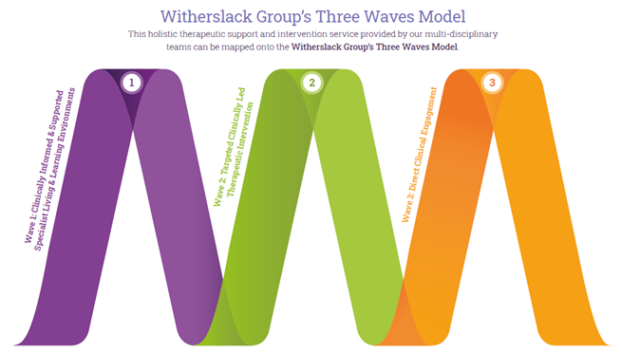

Wave 1: All staff support young people to create an inclusive working environment. Clinicians provide training to school staff to help them understand and meets the needs of young people with social communication difficulties, mental health difficulties and attachment difficulties.

Wave 2: Group work with staff and children directed by a clinician.

Wave 3: Individual 1-1 work delivered by a clinician to address more complex needs.

Every member of the therapy team receives clinical supervision on a regular basis from a senior practitioner appropriately qualified and registered with HCPC and BACP. Regular team meetings also take place for therapists facilitating the sharing of good practice and the dissemination of new initiatives

## Measuring the Effectiveness of Therapeutic Support

The effectiveness of the delivery of therapeutic services within the home setting is largely based on the structure of the support available to the young people in our care. The school has three therapists who provide on-site therapeutic support. This allows the young people a choice of whom they want to engage and work with for targeted interventions. Our therapists work together in supporting the young people and can aid each other in the work by offering ‘drop in’ sessions so that young people can have the extra emotional support throughout the week. The therapeutic teamwork in conjunction with the care staff team, attending team meetings and assisting them in working holistically with young people. Therapists also deliver tailored training to enable the team to gain a better understanding of the complex emotional difficulties that our young people are dealing with. Individual Outcomes and Targets for the young people in residential care are regularly reviewed during the delivery of therapy, at the Child-Focused Reflective Practice Meetings, at ITACs and at the Annual Review of the EHCP.

The effectiveness of the input and delivery of therapeutic services for young people at this stage of their lives and development not only helps them to have a better understanding of themselves and their needs in preparing to become young adults who can not only live comfortably in society and contribute to their community. It also gives them an understanding into how they can access therapeutic service in the future, ultimately giving them the self-advocacy skills and internal tools needed to be emotionally supported throughout their lives.

This internal, school-based clinical team allows us to give the young people the emotional and mental health support they need when they need it without the need for being placed on long waiting lists. The therapeutic team holds frequent and regular discussions about the young people in residential care. These are on both a formal and informal basis to ensure that the best possible care and individually tailored therapeutic support is provided. Each young person is recognized and celebrated as a valued and unique individual.

This immediate support helps to maintain the stability the young people in our care need and in many instances allows then to avoid going into crisis.

## 

## Staff Training, Development and Supervision

All residential staff employed engage in the Witherslack Group’s staff annual *Progress Review* which records details of their training and professional experiences, their qualifications and their agreed development goals to facilitate the provision of high quality care for young people. The development requirements are identified through supervision and the on- going supervision and review process.

This formalises an all-inclusive system of staff supervision, support, development and training. The Witherslack Group believes that staff support and development is a continuous process for all staff, whatever their role and responsibilities from appointment to leaving. It is a reciprocal process of mutual benefit to individuals, groups of staff and the establishment as a whole, and involves both formal and informal processes. These include using a variety of formats, including peer supervision, team meetings, handovers and termly individual, direct 1-2-1 supervision with a senior member of staff which promotes reflective practice.

Training and development is not viewed as a process separate from the individual’s day to day professional practice, indeed learning is most effective when individuals can identify a clear connection between theory and practice. As such the learning which occurs both informally and formally through day to day observation and feedback is as important as more traditionally based training.

## Organisational Structure

Head Teacher/ Head of Care

Residential Support

Workers x 3

Deputy Head of Care

Waking Watch x 1

Pontville’s residential care provision has a small staff team of both genders. The staff team have a vast amount of experience. The residential setting has an experienced and skilled staff team and regular reviews of the staffing profile of the home take place to ensure compatibility and skill set matching with the needs of the young people. We aim to provide a healthy balance of experience and gender to accurately reflect home contexts, and promote gender identity in our young people.

All staff hold an NVQ Level 3 in Caring for Children and Young People or the BTEC Level 4 Diploma for Residential Childcare.

## 

## Governance

Pontville School is a member of The Witherslack Group and as such benefits from the support afforded by an organisation which has extensive experience and a national reputation for the care and education of children and young people. There are regular meetings for Head of Care and staff that provide a forum for peer support and the dissemination of good practice.

Standard 3 visits take place each half term and carry out routine examination and scrutiny of different aspects of the home, such as health and safety, leadership and management as well as standards of care. The Head of Care is responsible for devising an action plan from any recommendations made and ensures that these are completed in a timely manner. An External Care review also takes place annually to ensure that the home is meeting all of the National Minimum Standards for Residential Special Schools.

## Children’s Behaviour

Staff accept that all children and young people may from time-to-time display behaviours which are outside of the norms of acceptability. To help our young people Pontville Residential Provision House has developed a positive management of behaviour policy, systems and processes in order to not only minimise risks for children, staff and members of the community, but also enable learning through resolution.

All staff have received training in Positive Behaviour Support which focuses on distraction, diffusion and de-escalation. A major aim of the home is to help young people develop appropriate internal working models of acceptable behaviour, and that positive behaviour patterns are associated with encouragement and reward.

Any disciplinary measures used are recorded contemporaneously and signed to verify their accuracy. Young people are also encouraged to record their views as this provides ongoing social learning opportunities and improved ownership. The Head of Care regularly monitors the use of disciplinary measures seeking out trends and patterns as well as analysis of their effectiveness and makes written recording to that effect.

Many children and young people will have past or current experiences which adversely affect their understanding of accepted behaviours, and this negatively impacts on their ability to regulate their behaviour effectively. Unfortunately this sometimes leads to times when young people may engage in behaviour that places themselves or others at risk of harm. In such cases external controls may be necessary and staff may use physical intervention as one strategy to keep the young person and others safe.

All staff are given Positive Behaviour Support training and physical intervention training (PRICE – Protecting Rights in a Caring Environment) and are re-accredited on an annual basis. PRICE is an accredited approach that promotes the least intrusive positive handling strategy, with an emphasis and preference for the use of verbal and non-verbal de-escalation strategies being used and exhausted before positive handling strategies are utilised. All staff receive PRICE training as part of their induction and this is followed up with 12 hours of annual refresher training. The focus of this training is in the promotion of a positive environment, the early recognition of warning signals, de-escalation and diffusion. All staff who successfully complete this training are assessed as competent and certified as such.

Staff receive extensive training and guidance in respect of creating a positive environment where relationships are based upon mutual trust and respect. Management techniques are reward focussed and involve a range of strategies including the use of positive reinforcement, modelling, incentives and individualised guidance and support.

The Head of Care regularly monitors the use of physical intervention to effectively analyse any trends and patterns to provide learning opportunities for staff and young people to seek to avoid the use of physical intervention wherever possible. The use of each individual young person ‘PBS Plan’ also assists staff and young people when dealing with future incidents.

## Emergency Procedures

We are fully compliant with all relevant fire safety legislation. Fire safety equipment is regularly serviced, inspected and if necessary repaired. Records are available on site. All children and staff are made aware of the fire evacuation procedure and assembly point should fire occur. All alarm tests and evacuation events are recorded and on file. We have a modern highly effective fire and smoke detection system which meets requirements. The school’s site manager checks the fire alarm system, conducts fire drills, reviews fire evacuation procedures and liaises with the Fire Brigade in respect of all fire safety measures. Emergency lighting is in place throughout the home and is checked in accordance with current legislation and guidance.

## Contact Details

## Head Teacher Head of Care

Mrs Hayley Dorian Mrs Hayley Dorian

Pontville School Pontville School

Black Moss Lane Black Moss Lane

Ormskirk Ormskirk

Lancashire Lancashire

L39 4TW L39 4TW

Telephone 01695 578734 Telephone 01695 578734

Email: [Hayley.Dorian@witherslackgroup.co.uk](mailto:Hayley.Dorian@witherslackgroup.co.uk)

**Witherslack Group**

Witherslack Group Lupton Tower Lupton

Cumbria

LA6 2PR

Tel: 015395 66081

Fax: 015395 66719

**Staffing Matters**

**Residential Staff Team**

|  |  |  |  |
| --- | --- | --- | --- |
| Name / Job role | Start date | Experience relevant to role | Qualifications relevant to role |
| Hayley Dorian  Head of Care | Pontville  01.09.24. | Hayley has over twenty years experience working in education settings, including those with residential care provision for young people with complex needs. Hayley is an experienced SEND leader. | BA (Hons) Education and English with QTS  Postgraduate Certificate in Education  Postgraduate Certificate in Autism and Asperger Syndrome  NPQH |
| Callum Rothwell  Deputy Head of Care | Pontville  18 04 17 | Over 10 years’ experience of working with and supporting people with autism, Callum was a senior support worker within the adult sector before moving into his current role. | BTEC Diploma level 3 & 4 in residential childcare. |
| Joy Green  P/T Residential Support Worker | Pontville  05 12 16 | Over 25 years’ experience working with adults and young people with learning difficulties within the care sector. Joy has worked for several different companies gaining a broad knowledge in this area and experience. | NVQ level 3 in Care. |
| Jayne Cooper  Residential Support Worker | Pontville  04 03 19 | Previous experience of supporting reading sessions in a mainstream primary. Jayne previously worked for 30 years at Boots as a pharmacy assistant. | BTEC Diploma Level 3 & 4 in residential childcare |
| Lynn Briant  P/T Residential Support Worker | Pontville  03 09 96 | Over 25 years’ experience, working with children with special educational needs. Lynn has been working at Pontville since 1996 and has been a senior residential support worker in the past prior to working part time. | NVQ 3 Caring for Children & Young People |
| Rebecca Seddon  Night Supervision Officer | Pontville  18 11 19 | Rebecca previously worked as a Residential Support Worker for 12 months in a Children’s Home. | Level 2 in Children’s care, learning and development  CACHE Level 3 Diploma for the Children and Young People’s workforce  CACHE Extended Level 3 Diploma for the Children and Young People’s workforce  NCFE CACHE Level 3 Preparing to work in social care  NCFE CACHE Level 2 Rights in Health, Social Care or Children and Young People Settings |