



**Welcome to Oakwood -   
Pontville School’s 38 week  
Residential Provision**

**Children’s Handbook**

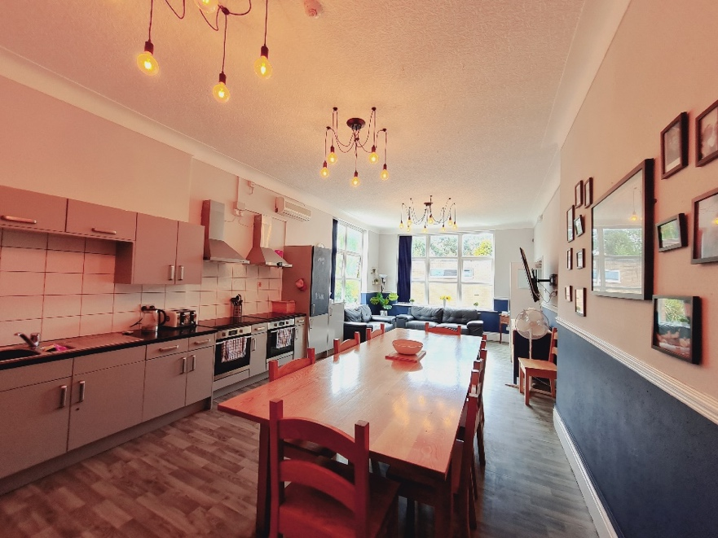

**About this booklet**

This booklet is to help you to understand a little bit about Pontville’s Residential Home, which we call Oakwood, before you arrive. You may have to ask your parent or carer to help you to read it, as some parts may be hard to understand.

What’s included in this booklet:

Page 3: Important information – Details of things that will be important to you whilst you live in Oakwood.

Page 4: Meet the staff team – This will help you to familiarise yourself with the staff team who will be working with you in Oakwood.

Page 5: Complaints procedure – How to make a complaint, who you can turn to and how to access an independent person

Pages 6 & 7: Your house – A look at the home where you will be living

Page 8: House rules – These will let you know what will be expected of you whilst living in Oakwood

Page 9: What happens each day – What time you get up, what time you go to bed etc

Page 10: Your school – A look at the school you will be going to and the sort of lessons you will be doing there

Page 11: The local area / activities – A brief guide to what is close to the home and a look at the sort of things you will be doing after school.

Page 12: Frequently asked questions from previous young people – What other young people feel you should know before joining us

Page 13: Finally an opportunity for you to ask any questions you may have for us

**Important information**

Point’s money – You will be able to earn up to £8 a week in points money. You can earn your points money by completing daily tasks assigned to you, these can be anything from being kind to others to washing your dishes. Your keyworker will set your points targets with you each half term.

Phone calls – You will have access to a landline phone to call home, friends and family if you wish to or you can use your own devices if you want to.

Wi-Fi – Whilst staying in Oakwood, you will be able to access the school’s Wi-Fi, this is filtered to keep you safe online.

Visits to and from special people in your life – Staff need to be made aware of any planned visits so they can support you with this.

Visits to see if you’re happy – Each month we have a visitor to make sure that everything is okay and you can talk to them about things you have been doing and anything that you may be worried about. Every month we have another visitor who checks that you are well looked after and that the home is safe for you to live in. Once a year we have an inspection from Ofsted and they will ask to talk to you about what it is like living in Oakwood.

Medical needs – Most young people remain registered with their own GP, if you are not feeling well, let a member of staff know, we can access our local walk in centre and A & E department if needed. We also access a local dentist and opticians for regular check-ups. If you take medication this will be locked away and given to you by staff unless you are able to administer this safely on your own.

Therapies – You will meet our clinical services team during your time with us, sometimes they will visit you in Oakwood to do a planned session with you.

Access to your room – You will be given a key to your bedroom, staff will go in your room during the day whilst you are in school to make sure it is clean and tidy.

Fire drills – These take place once a term, this is to make sure that in the event of a real fire we know that you can leave the building safely.

**Meet the staff team**

|  |  |  |
| --- | --- | --- |
| **Hayley Dorian – Head of Care**  Hayley works Monday-Friday during the school day and is available on-call out of school hours. | C:\Users\dkervin\AppData\Local\Microsoft\Windows\INetCache\Content.Outlook\TLQMA63B\2016.01.24-Staff ID-Rothwell C.jpg  **Callum – Deputy Head of Care**  Callum works on a Monday, Tuesday and Thursday evening, he works each Wednesday and Friday morning. | C:\Users\dkervin\AppData\Local\Microsoft\Windows\INetCache\Content.Outlook\TLQMA63B\2019.01.21-Staff ID-Cooper J.jpg  **Jayne – RSW**  Jayne works on a Monday, Wednesday and Thursday evening, she works each Tuesday and Friday morning |
| C:\Users\dkervin\AppData\Local\Microsoft\Windows\INetCache\Content.Outlook\TLQMA63B\2018.01.24-Staff ID-Green J.jpg**Joy – RSW**  Joy works on a Tuesday and Wednesday evening and on a Thursday morning | C:\Users\dkervin\AppData\Local\Microsoft\Windows\INetCache\Content.Outlook\TLQMA63B\2012.11.26-Staff ID-Briant L.JPG  **Lynn – RSW**  Lynn works on a Tuesday and Thursday evening and a Wednesday morning. | . C:\Users\dkervin\AppData\Local\Microsoft\Windows\INetCache\Content.Outlook\TLQMA63B\2019.10.17-Staff ID-Seddon R.jpg **Becky – Waking Night Staff**  Becky stays awake all night Monday to Thursday. |

**Complaints procedure**

We would like your time in Oakwood to be a happy time and we hope that you don’t have cause for complaint but if you do feel that you need to complain about something which may be worrying you there are a number of ways to go about this:

Talk to a member of staff about your concerns

Talk it over with your keyworker (You will be given a keyworker before you start)

Talk to Mrs Dorian, our Head Teacher

If you are still unhappy or don’t feel you can talk to any of the staff available you can access our independent person or our advocate – details are on our notice board in the main bedroom corridor.

Other people you can contact are:

* Your social worker (if you have one)
* Your Independent Reviewing Officer (if you have one)
* Ofsted 0300 123 4666
* Childline 0800 1111
* NSPCC – 0808 800 5000
* The Children’s Commissioner – 0800 528 0731

Within school and residential any safeguarding concerns in relation to young people are taken seriously. Processess are in place for the staff to ensure they undertake their duties and ascertain the safety, health and wellbeing of all of the children in Oakwood, at all times.

  

**Your house**

The name of our residential home at Pontville School is Oakwood and we are situated on the main school site in Ormskirk.

Oakwood has seven bedrooms, this is one of the bedrooms to give you an idea of what your room could look like:

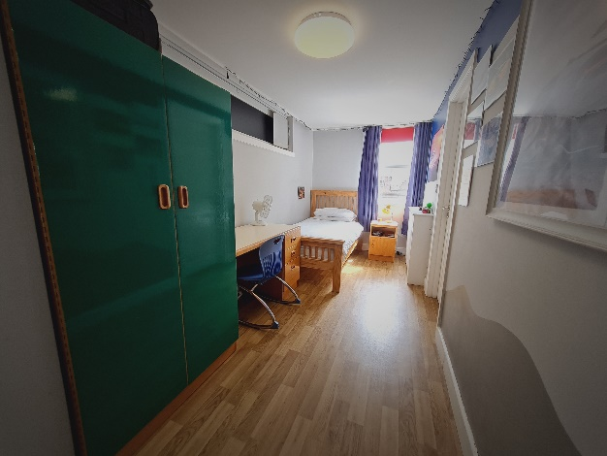

Each young person has a room of their own with an en-suite bathroom that has a shower, sink and toilet. You will be responsible for keeping your room tidy with the help from staff.

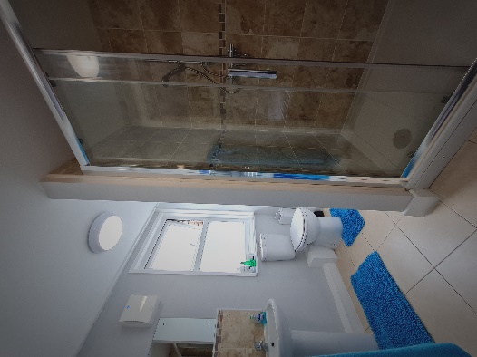

We would like you to personalise your room when you start with us, you can decorate with your favourite colours, choose your own bedding and put pictures and posters on your walls. It’s really important that you make this ‘your’ bedroom where you feel comfortable and safe.

This is our main bathroom, for when you might want to have a nice soak and relax in the bath.

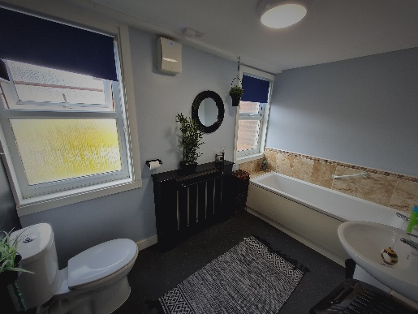

This is the lounge / kitchen / dining room, our main area where we can spend time together.

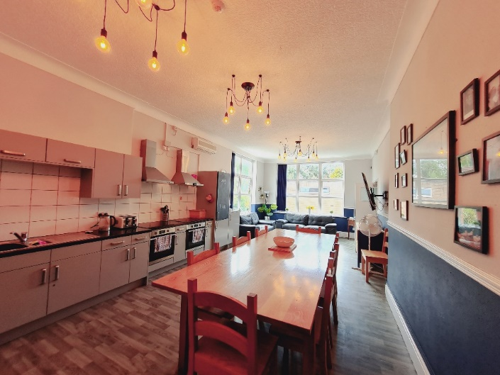

This is our ‘comfy room’. This is a nice space to relax, do crafts, watch TV or use the computer. You can also use this room to meet with any visitors that you might have so you can talk in private.

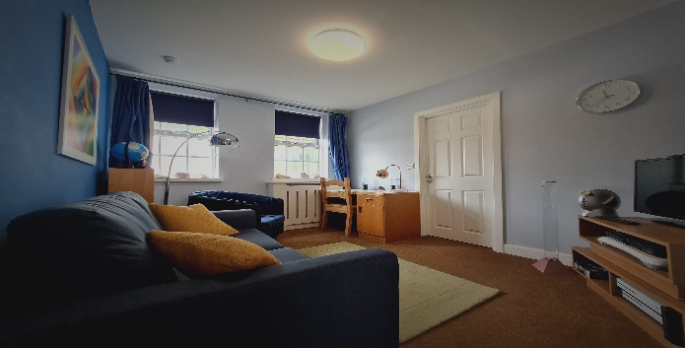

**House Rules**

In Oakwood all staff take your care and welfare very seriously. There are a number of rules and guidelines that you will be expected to follow whilst you are living here. They are in place to make sure that your care and safety is a priority and also to make sure that Oakwood is a nice place to live in.

When you arrive in Oakwood you will be involved in setting up these rules so that you feel they are fair.

Before you join us in Oakwood there is one rule that you will need to know and that is we do not tolerate any form of bullying.

The support and care we give within Oakwood is arranged in a way that no young people will be left alone for long periods of time and staff are available for you.

Risk assessments and care plans are in place to ensure staff get to know you well, what you like and how best to support you.

During the night we have two members of staff who stay awake all night, they are there if you need anything during the night or need some help to settle to sleep.

Staff will go through all of this with you when you arrive in Oakwood.

|  |
| --- |
| **House Rules**  Respect each other  Keep it clean  Use manners  Follow guides  Take responsibility  Stay safe  Communicate honestly  Show gratitude  Have fun |

**What happens each day**

07:30 – 08:45 – Time to get up, ready and have breakfast before going down to school

08:45 – All young people go to school or the 16-19 centre, depending on where you are that day

09:00 – 09:10: Form time

09:10 – 09:55 Lesson 1

09:55 – 10:40: Lesson 2

10:40 – 10:55: Break Time

10:55 – 11:40: Lesson 3

11:40 – 12:25: Lesson 4

12:25 – 12:55: Lunch (First sitting) & activity

12:55 – 13:25: Lunch (Second sitting) & activity

13:25 – 14:10: Lesson 4

14:10 – 14:55: Lesson 5

14:55 – 15:00: Transition and transport.

15:00: Return to Oakwood residential

17:00: Evening meal (time can vary due to activities)

17:30: Evening activities

19:30: Onwards bedtime routines to start (age dependent)

**Your school**



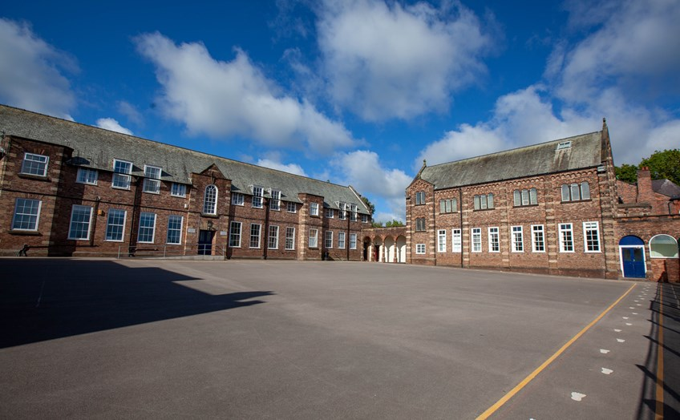

When you live in Oakwood you will attend Pontville School in Ormskirk or our 16-19 centre in Skelmersdale.

Oakwood is on the main school site so you can go down to school at 08:55 and return at 15:30, staff will take you down to school in the morning and collect you from the yard at the end of the school day.

If you are going to our 16-19 centre, school staff will transport you there and back each day.

Pontville can take up to 155 pupils. You will have all the usual lessons that you have in a primary or secondary school. You can do vocational courses over at the 16-19 centre too. School staff will make sure that the timetable is right for you.

**The local area**

The town centre is within walking distance from school and there are lots of things to see and do to keep us busy and active. There is a swimming pool, gym, park, library, lots of shops – the lists goes on and on.

On site we have access to the MUGA, Forest School area, farm, outdoor gym and the school hall where you can take part in music sessions.

**Activities**

In Oakwood we love doing different activities and encouraging you to enjoy your own interests too.

You will be asked what sort of things you would like to do and if there are any local groups you would like to join such as badminton, drum lessons, swimming sessions and youth clubs.

Some young people go out on their own, this depends on their age and ability and mainly once we all get to know each other.

We also do lots of group activities, both on site and off site. Children enjoy going bowling, climbing, visits to the beach, local cafés and lots more.

We have access to a number of the school vehicles of an evening, so we can travel with no problems to anywhere fun that you have in mind.

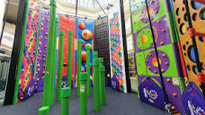 

**Frequently asked questions**

Can I decorate my bedroom? Of course. You can personalise it with your favourite colours, wall paper and pictures.

How will I talk to my family? During the week, you can contact your family whenever you need to, unless there are reasons why you can’t do this.

Will I get to spend money? You won’t get pocket money, instead you will be able to earn points money based on targets set for you each half term. You can earn up to £8 a week. Staff will take you shopping when you want to go and buy something.

What if I am worried? You can talk to any of the staff in Oakwood. You may also like to talk to our visitors when they come to see you.

Can I see my friends? Where possible we will support you to visit your friends or invite them for a visit to Oakwood.

Can I attend my meetings? You will be encouraged to take part in all meetings about you.

Will I have a TV in my room? We will provide you with a TV and DVD player when you start.

Will I get birthday presents? Yes. Your keyworker will ask you what you would like.

**Do you have any questions to ask us?**

If you can think of any questions to ask us, big or small, then use this space to write them down and we can answer them for you ☺